# Contributors

Gus - core

Paolo - refactoring and cooldowns

Anton - timeline

# High Level Overview

The player HUD (heads up display) includes various UI elements overlaid on the actual game. These UI elements are made up of the following:

## Game Timer

This is a text element that appears in the top left of the screen [1]. It counts down the time during the game (i.e. from 5:00 to 0:00).

## Team Indicator

This is a text element that appears in the top right of the screen [1]. It displays the player’s team (i.e. HIDER or SEEKER).

## Master Client Options

This is a text element that appears in the middle of the screen [2]. It is used to display messages for the master client. For example “Press ‘e’ to start”, “Starting in 5s”, “Loading…”, etc.

## Game Start Timer

This is a text element that appears in the middle of the screen [1]. It displays the time until the game begins.

## Debug Panel

This is a panel on the left hand side of the screen [1]. It is normally hidden but its visibility can be toggled on/off when the user presses ‘p’. It displays a list of debug items in the following format:

<name>: <value>

The programmer can easily set these items in code, choosing which values they’d like to have displayed.

## Timeline

The timeline appears at the bottom of the screen [1] and is made up of several components:

* A time bar, which represents the timeline itself. As the game progresses, it fills from left to right.
* Player icons, which represent player positions on the timeline
* Cooldown icons, which represent whether or not a player can travel in time. There are two of these; the left one is for jumping backwards and the right one is for jumping forwards. Each icon is a button that is green when it’s possible to jump and red when it’s not possible. A coloured bar fills behind them as they “recharge”.

# Implementation

The HUD appears under the Player prefab in Unity and the associated code is in PlayerHud.cs. All UI elements get updated and displayed in the LateUpdate() method. This in turn calls a helper function for each of the following UI elements:

LateUpdateMasterClientOptions() sets the visibility and text to be displayed for the Master Client Options.

LateUpdateStartTimeDisplay() sets the visibility and text to be displayed for the Game Start Timer.

LateUpdateTimeDisplay() sets the visibility and text to be displayed for the Game Timer.

LateUpdateTimeline() sets the visibility of all the components in the timeline. It then sets the position of each player’s icon on the time bar.

LateUpdateDebugPanel() sets the visibility and text to be displayed in the debug panel.

LateUpdateCooldowns() sets the height of the cooldown bars and the colour of the buttons.

LateUpdateWinningDisplay() sets the visibility and text to be displayed on the winning display.

This script also has a bunch of public methods that can be called from PlayerMovement.cs. Most of these should be self-explanatory.

SetDebugValues() takes in a hashtable as an argument. The items in the hashtable should be of the form name: value, where name is a string descriptor for this item and value is the debug value (of any type) to be displayed.

SetCooldownValues() takes in an array of the cooldown values. These should be a float between 0.0f (empty) and 1.0f (full) to describe the height of the cooldown bars. The first value refers to the left (backwards) cooldown and the second refers to the right (forwards) cooldown.

# Screenshots

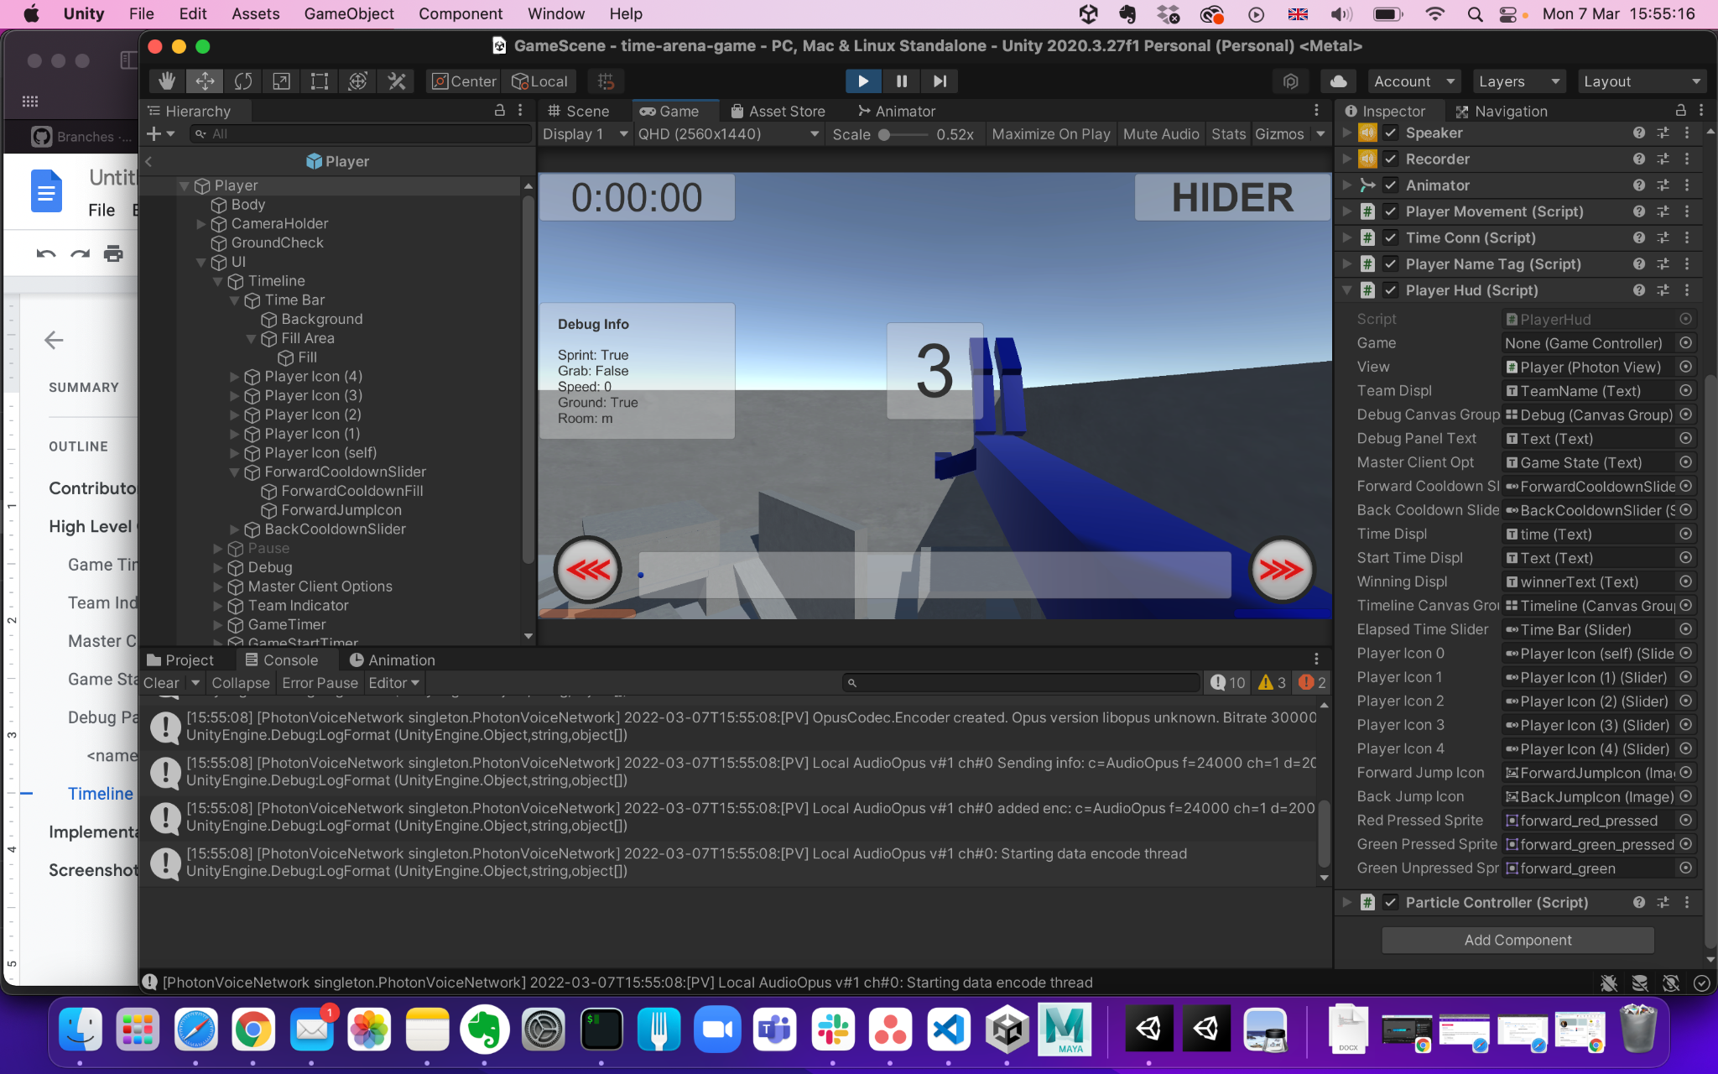

*Image 1: HUD during the game. The game timer is in the top left, the team indicator is in the top right, the debug panel is in the middle left, the game start timer is in the middle and the timeline is at the bottom. The time bar is in the center of the bottom. The player icon of the user is on the time bar. The backward cooldown is on the bottom left and the forward cooldown is on the bottom right.*

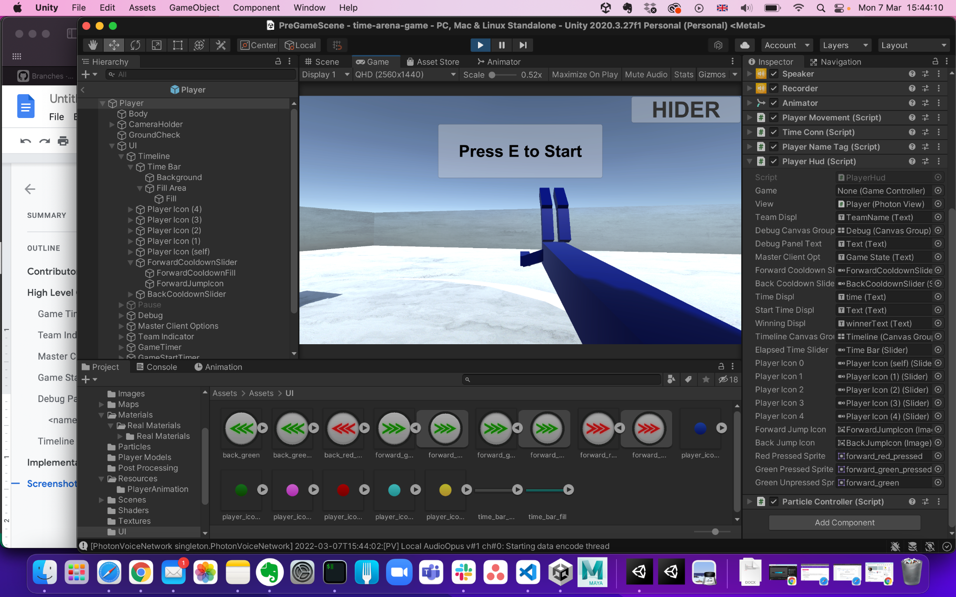

*Image 2: The HUD during the pregame scene. The team indicator is in the top right and the master client options are in the middle.*